**Setting up Application Environment**

**Creating SendGrid Account**

**STEPS TO CREATE SENDGRID ACCOUNT**

The following procedure is followed to create the SendGrid account.

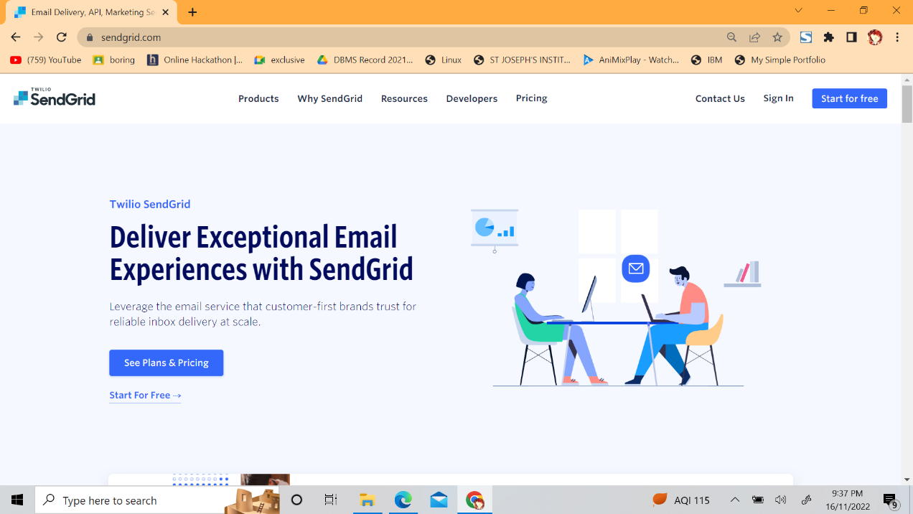**STEP 1 :** Navigate to <https://sendgrid.com>­­

**STEP 2 :** Click on “Start for free” and register yourselves by entering required details and click on create account

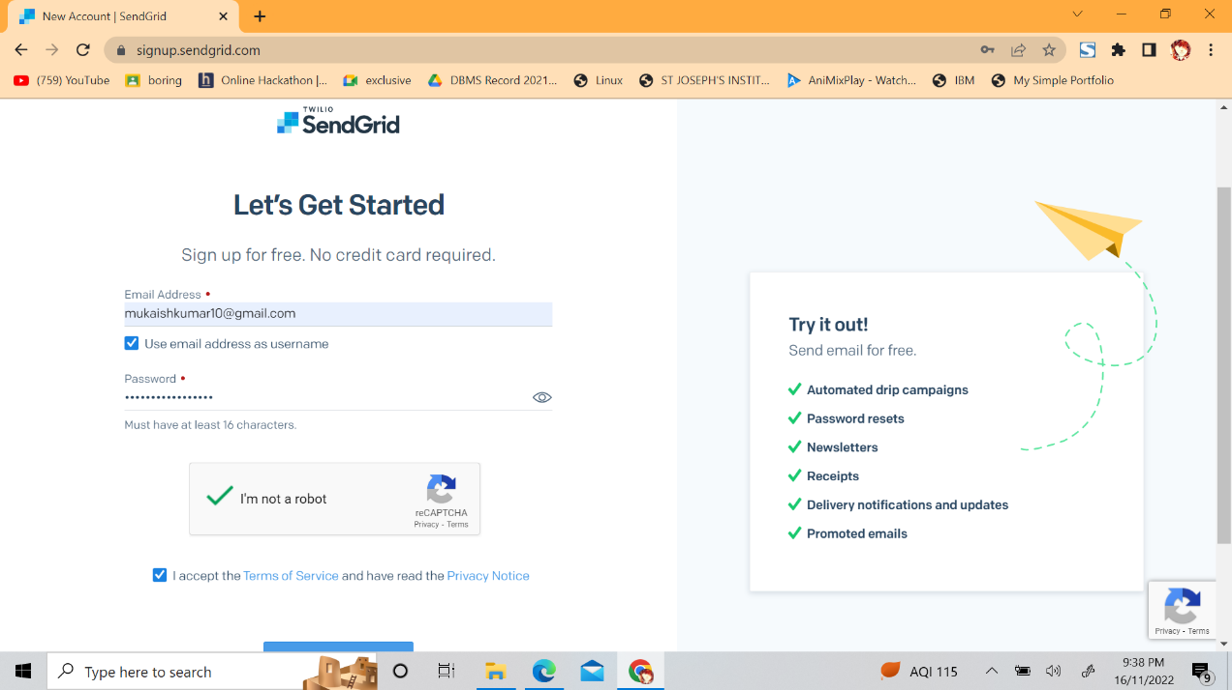

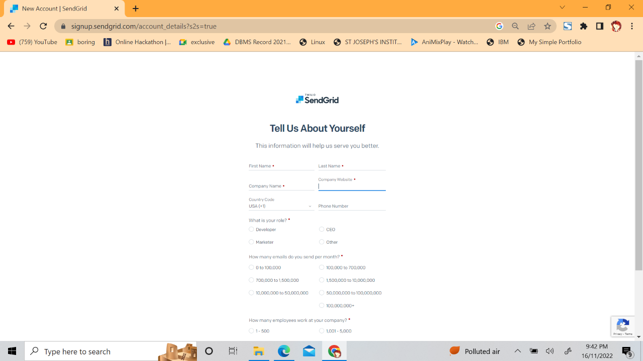**STEP 3 :** . The next step is to fill all required details in next page and click on get started as shown below.

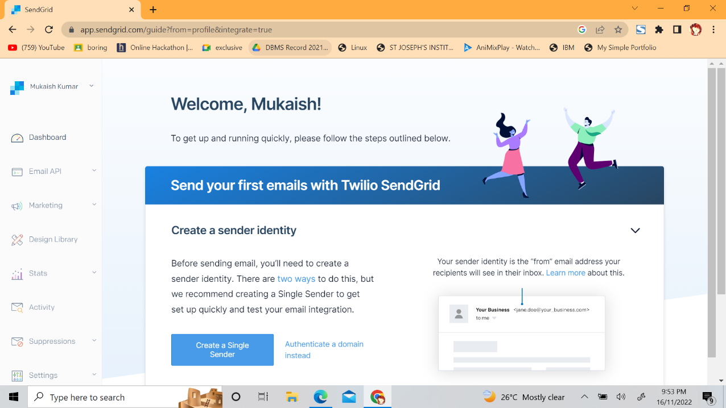**STEP 4:** The account will be created and the dashboard will appear.

The SendGrid account would be created.